IT24101780

Wanigasekara Y.A.

Lab 06

Probability and Statistics

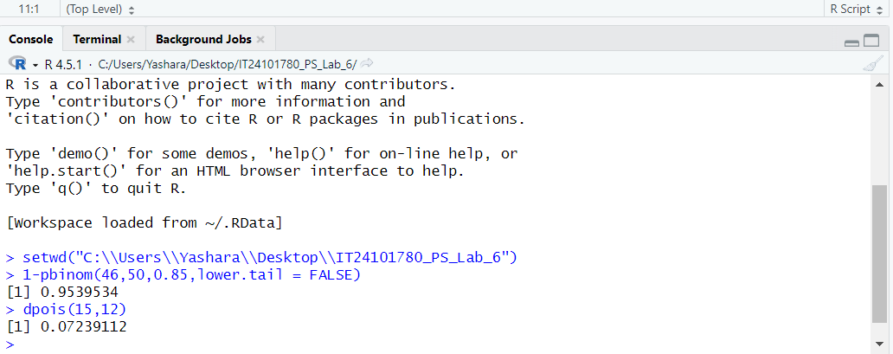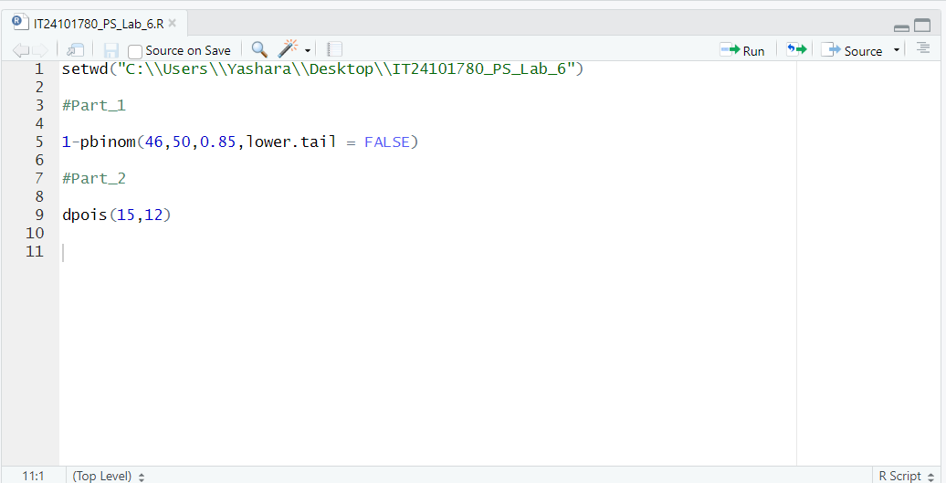

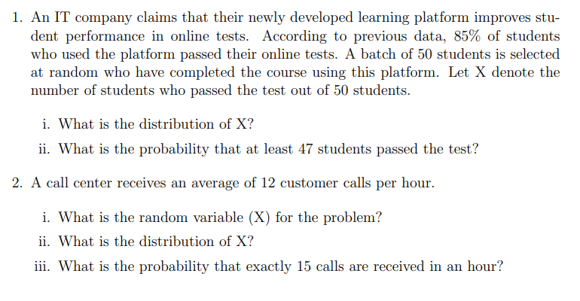

Part 1

1.) Binomial Distribution

Number of trials, n=50

Probability of success, p=0.85

2.)



Part 2

1.) Number of customer calls received in one hour.

2.) Poisson distribution

Average rate (λ) - 12 calls per hour.

3.)

